Claude, there are significant changes in this document to the current structure of the app, so would like to build this out as a new branch.

General items
Login - is not carrying over profile between devices. Is this a deployment issue or do we need to reconfigure the user profile to ensure the same login carries across devices and browsers?
The login is quite slow, taking over 5 seconds to load. Can this be optimised through memory?
In terms of reporting / progress page:
- A graph of total set volume per week (sum of sets and sum of total load), with a drop down that allows the user to select a particular muscle group (e.g. quads, hamstrings, biceps)
- A table of RMs for each exercise in the active phase. Something like
Exercise | Est 1RM | Est 5RM | Est 10RM | Last Lift (date)
e.g. bench press | 65 | 57.5 | 52.5 | 10x50kg (24/1/26)

Training block – Phase – Week structure
Want to change the structure of what’s presented under Training block, phase and week.
To begin with, a user should be able to edit the name of the training block in the below image 1. Rather than hold all of the phase and week details in the training block screen, this screen should really act as an outline of the training block and allow for edits to the key variables selected through the guided training block build.
- How long is the training block (should be listed next to the Training Block title, and be editable.
- How many days per week training in each of the phases (
- What is the training split in each of the phases
- Allow for entry of what is the goal for each phase (i.e. hypertrophy, maintenance, strength, power – drop down list with option for free text)
- Clicking on any of the Phase titles should then allow the user to go through to the Training Phase overview page.
I like the Phases stacking on top of one another, just take out the week detail, as we’ll combine that with some of the “week view” in a “Phase overview” page. We also need a validation that only allows one training block to be active. A user can add many, but only one can be active at a time – the others should be for a different date range, or saved as a draft.

Image 1
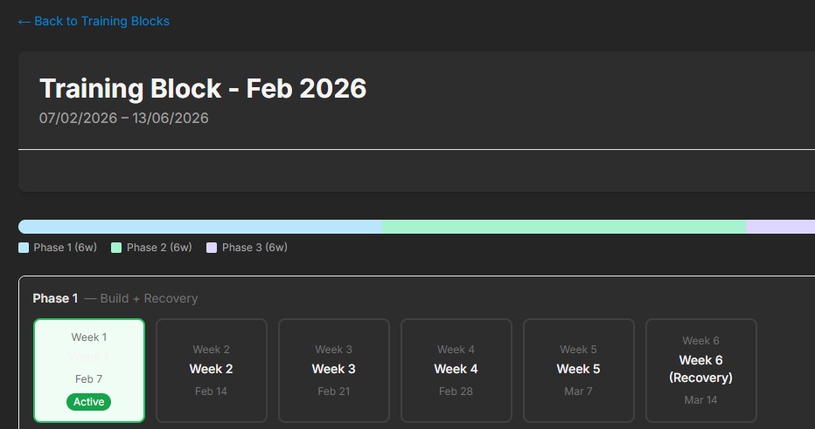
Create a new “Training Phase Overview page”
The phase overview page should be a trimmed down version of the phase overview that is currently in the Training Block screen, with some functions that are currently housed on the Week summary screen (Image 2). This should only display the phase that was clicked on from the training block overview.
Image 2 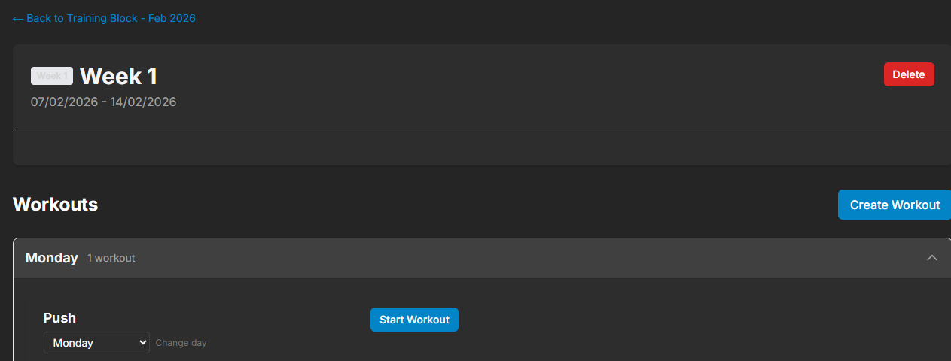

In this page, should replicate the horizontal week view that currently exists in Image 1, but rather than click between weeks to see detail, the user should be able to Swipe left/right to scroll through weeks, and scroll down to see the the workouts in that week. At the moment, clicking on the week shows a set of preview cards (Image 3) – these can be removed in favour of simply displaying the workout exercises as per Image 4. Ideally, these workout cards are collapsed so a user clicks on a week and sees the days/titles (e.g. Monday Push) stacked on top of one another, and then clicks again to expand the specific workout. For each workout in the week, the user should be able to change the day, as well as drag and drop the workouts into a different order. The user should also be given an option at the week, and workout level, to apply the changes they have made to the rest of the phase. The user should be able to add/edit/remove exercises under each workout, and set the desired sets, cadence, RIR, rest time for each exercise. Enable editing of all workouts apart from those completed on this page, but Allow change of day /date on any workouts whether completed or not. In each workout, and for the phase, allow for a warm-up section(effectively notes). Show the week number in the workouts page as part of the title (ie next to push - week 1 push) and the date/day below (editable)
Image 3
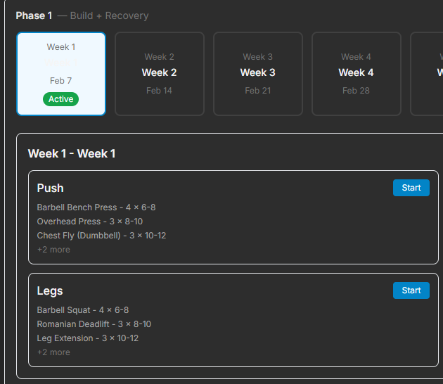

Image 4
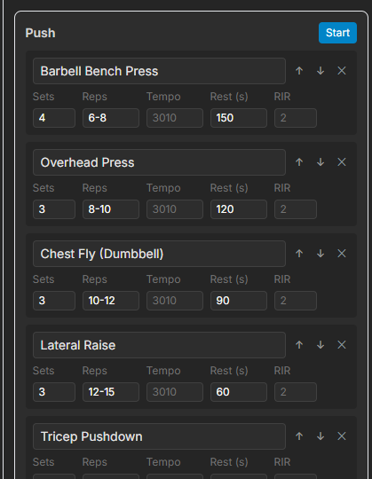

IN the workout page
Remove notes for each set, just have a note for each exercise at the end. Have an RPE field at the end of the last set with a 1(too easy) to 5(too much) in a drop down. These should be used to calculate an overall RPE for the workout which is presented on completion. On completion of the workout, show an up next message which informs the user the next work out and day (ie week 2 pull, Tuesday, 21st). When the user hits complete and fields are missing, warn the user that all uncompleted sets will be zeroed out (same function as skip). If they select ok, allow workout completion. Offer a 'no, resume workout' alternative. Single side exercises (e.g. split squats) – need the ability to record side splits (reps for Left and Right) and ability to trigger rest more than once per set (60s after left leg, and again after right leg). Ability to couple sets as a super set (i.e. they are performed one after another without rest) – this could be as simple as having a tick box against each exercise after the first one in the workout “superset?” which then pairs the exercise with the one before it.

Skip sets should strike through but preserve the intended load. Delete should completely remove the set

Adjusted Dashboard View
- Next workout should be the first option displayed as a prominent card– show the day it’s due, the type of workout (push, pull, legs, upper body).
- Should also list the week and phase against the workout due, e.g.
  - Next UP
    - Monday Upper Body
    - Week 2, Phase 1
- Log a manual workout should be it’s own distinct button, but at the bottom of the page.
- Show the current phase in a graphic similar to below to demonstrate where the user is up to.
- 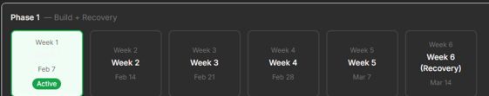
- Show a more granular daily calendar in a horizontal bar with a lifting symbol denoting which days have had workouts in the last month
- A graph of total set volume per week through the current phase

The training block menu page
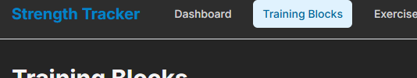
This is where the user should eb able to create new and click through to existing training blocks like current. Validations need to eb in place that only one block can be active. User should be able to edit the status in this page, clone a block, or delete a block. All of these setps should be issued with a warning for the user to authorise.

